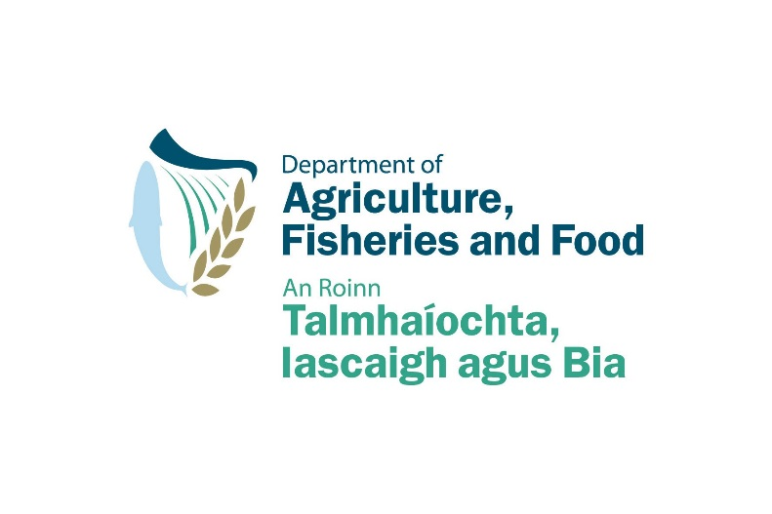

Food Institutional Research Measure (FIRM)

FIRM plus

Application Form

DEADLINE FOR COMPLETE PROPOSAL SUBMISSION
IN PDF VIA EMAIL TO research2010@agriculture.gov.ie:
Tuesday 7 December 2010 @ 1pm

All applications will be treated in confidence and no information contained therein will be communicated to any third party without the written permission of the applicant except insofar as is specifically required for the evaluation of the proposal.

Funded by the Irish Government under the National Development Plan 2007-2013

For official use only
Project Ref. No.
Date Received

SECTION 1:
PROJECT DETAILS

Food sector in which your innovation is expected to have most impact (tick one box only) | Dairy
 | Meat
 | Prepared consumer foods
 | Foods for particular nutritional uses
 | Beverages
 | Marine
 | Fresh produce and cereals
Project Title
Acronym
Existing/previous FIRM project title and DAFF project number
Lead Institution
Principal Investigator
Project Coordinator
Address

Telephone No. |  |  | Fax No.
Mobile No.
Email
Start Date |  | End date (max. 12 months from start date)

Collaborating institutions
Name of Institution | Total Project Cost  € | Total Grant Request  €
1.
2.
3.
4.
5.
OVERALL PROJECT COST

SECTION 2:
PROJECT INFORMATION

Please consult the Guidelines for Applicants for further information on completing the application form. Failure to fully complete this section may lead to your proposal being deemed ineligible for funding.

2.1 Project abstract (up to 300 words)
.
.
.
.
.
.
.
.
2.2 Project proposal (up to 5 pages)
In presenting your project proposal you should structure the content under all of the following headings:

2.2.1 Provide evidence of commercial need for your proposed project

2.2.2 What is the particular impact that your proposed project would have commercially in the Irish food sector and the wider Irish economy at large?

2.2.3 What is the specific problem to be addressed by this proposal? What are the expected outputs?

2.2.4 Provide a background description/data on current FIRM project on which this is based.

2.2.5 Describe your track record in relation to innovation and commercialisation (incl. details on Enterprise Ireland funding awarded to date and any other commercialisation funding awarded from any other agency)

2.2.6 Describe your track record with respect to research management and project management in this area of research

2.2.7 Provide evidence regarding the Freedom To Operate (FTO) status of your proposed project

SECTION 3:
BUDGET

3.1 Proposed budget (complete the following table)

 | Budget per Research Organisation
 | Institution 1 | Institution 2 | Total
Category of expenditure | € | € | €
Contract staff
Temporary staff
Post doctorates
Consumables
Travel and subsistence
SUB TOTAL
Other (incl. subcontracting)
Overheads (max 30% of direct costs)
TOTAL GRANT REQUESTED
Funds from other sources
TOTAL PROJECT COST

3.2 Justification for budget under the following headings: staff, T&S, consumables and any other eligible costs.

Staff

Travel and subsistence

Consumables

Other eligible costs

SECTION 4:
DECLARATION

Failure to provide all three signatures requested will result in your proposal being deemed ineligible.

I declare that the information contained in this application is true to the best of my knowledge and belief, and that this project is/will not be the subject for grant aid from any other source other than that indicated in the Budget Table above.

Signed: __________________________________ (Project Coordinator)_________________________

Print Name:____________________________________ Date:_____________________________________

Signed: (TTO or equivalent)____________________________

Print Name:___________________________________ Date:_______________________________________

Signed: (Authorised officer within lead institution)

Print Name:___________________________________ Date:_________________________________________

